OPEN ENDED LAB

Task-01
Design a Java program that simulates a login system.include valid exception for handling error
CODE:
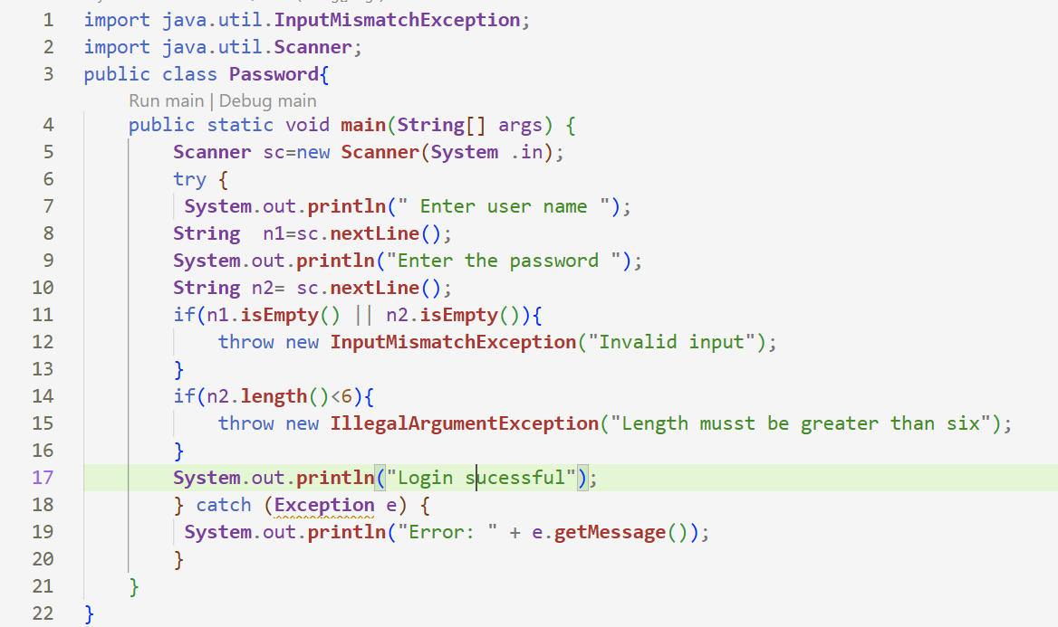
OUTPUT:
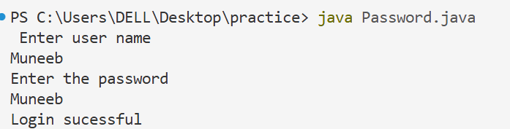

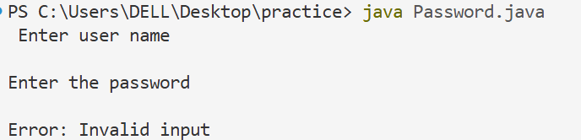
Task-02
Design a program to calculate average marks of a student.and include valid exception for handling error
CODE:
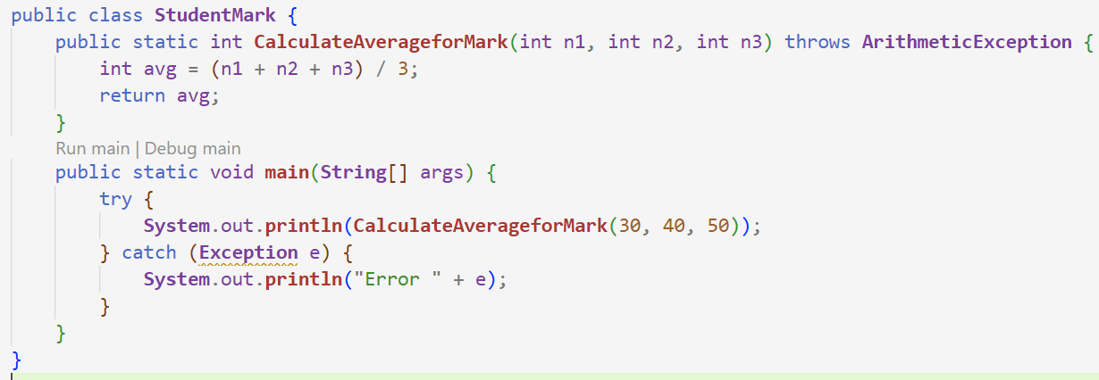
OUTPUT:
